SIMATS ENGINEERING (SAVEETHA SCHOOL OF ENGINEERING)
Department of Computer Science and Engineering

ASSESSMENT TOOL 1 – Coding Challenge Task

Course Code: | CSA06 | Course Title: | Design and Analysis of Algorithms
CO Assessed: | CO4: Articulation (BL4, BL5) | Assessment: | Assessment Tool 1 – Coding Challenge Task
Weightage: | 40% of CIA | Total Marks: | 100
CO4 Statement: | Solve optimization problems using dynamic programming and greedy strategies.
Student Name: | A VELMURUGAN | Reg. No.: | 192521074
Section / Batch: |  | Date: | 19/8/2026
Instructions to Students
- Answer the following question. Total Marks: 100.
- Carefully analyze the given questions.
- Write clear code for the given problem.
- Analyze the Time complexity and Space complexity of your code using dynamic programming and greedy strategies

Question Type | Focus Area | Questions
Coding Challenge Task | Focus on Code and analyze optimization problems using dynamic programming and greedy strategies | Q1

SECTION A – Coding Challenge Task

Q40. Maximum Length Chain of Pairs
Given pairs of numbers where each pair has a start and end value, the goal is to form the longest chain such
that the end of one pair is less than the start of the next. Efficient selection is required to maximize chain
length. Use Greedy or Dynamic Programming techniques.

Sample Input:
n = 3 pairs = (5,24) (15,25) (27,40)
Expected Output:
Max Chain Length = 2

Code of Conduct
I A.VELMURUGAN (192521074)Name / Reg No) certify that this submission is my original work and that I have adhered to the guidelines specified for this assessment. I understand that any violation of academic integrity rules will result in disciplinary action.
Signature of the Student: A Velmurugan

Aim
The aim of this case study is to solve the Maximum Length Chain of Pairs problem using the Greedy Algorithm. The program finds the longest possible chain of non-overlapping pairs efficiently. It sorts the pairs in ascending order based on their ending values before selection. The earliest finishing pair is always chosen to maximize future opportunities. This approach reduces unnecessary comparisons and improves performance. The algorithm provides an optimal solution for interval scheduling problems. It helps in selecting the maximum number of compatible pairs from the given input.

Objectives
The main objectives of the Maximum Length Chain of Pairs problem are:

- To read the start and end values of all pairs.

- To arrange the pairs in ascending order of their ending values.

- To apply the Greedy Algorithm for optimal pair selection.

- To select only non-overlapping and compatible pairs.

- To maximize the total number of pairs in the chain.

Problem Analysis
The Maximum Length Chain of Pairs is a classic optimization problem that is efficiently solved using the Greedy Algorithm. In this problem, each pair consists of a start value and an end value, representing an interval. The objective is to connect the maximum number of pairs without overlapping. A pair can be included in the chain only when its starting value is greater than the ending value of the previously selected pair.
End of previous pair < Start of next pair
To get the maximum chain efficiently, we use the Greedy Algorithm by sorting the pairs according to their ending values and selecting compatible pairs.

Sample Question

n = 3

Pairs: (5,24), (15,25), (27,40)

Step-by-Step Execution
Step | Pair | Condition | Result
1 | (5,24) | First pair | Selected
2 | (15,25) | 15 ≤ 24 | Skipped
3 | (27,40) | 27 > 24 | Selected
Maximum Chain: (5,24) → (27,40)
Maximum Chain Length = 2

Python code
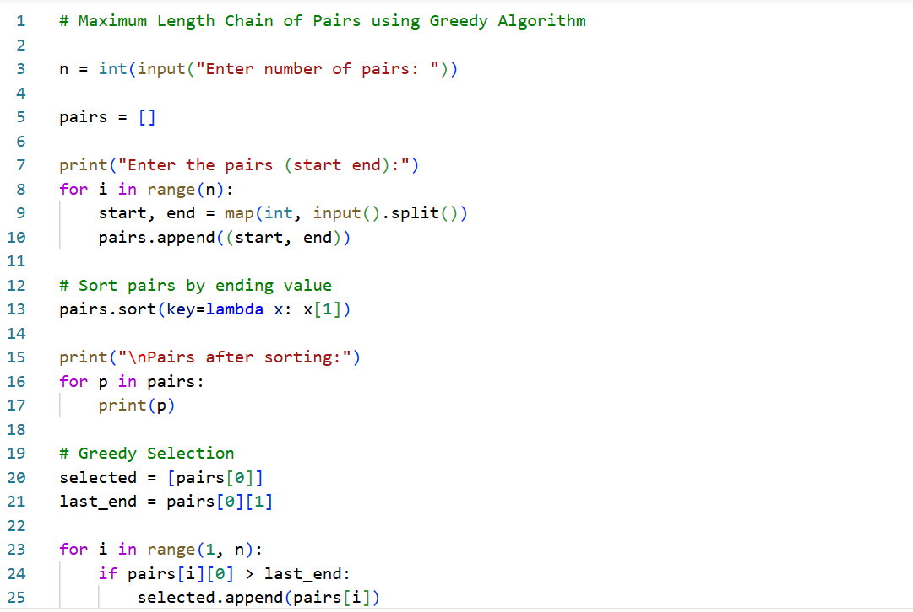

Input / Output
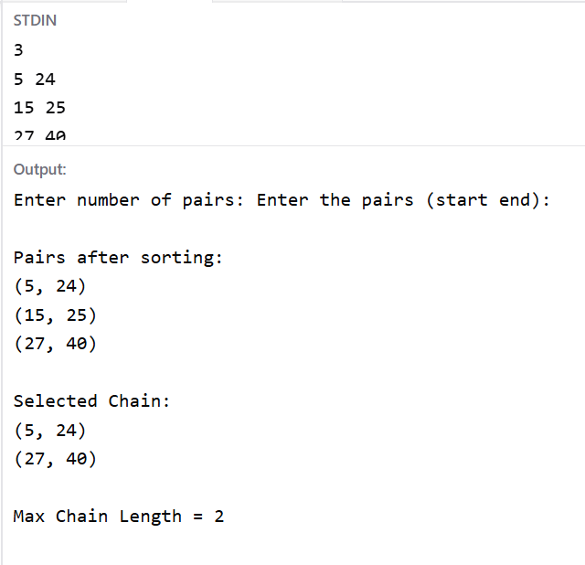

Time Complexity

Operation | Complexity
Sorting | O(n log n)
Greedy Selection | O(n)
Overall | O(n log n)

Result

The program successfully finds the maximum length chain of pairs using the Greedy algorithm. For the given input, the maximum chain is (5,24) → (27,40) and the maximum chain length is 2.

